WELCOME!
WE ARE A CONSTITUTIONALLY COMPLIANT FREE ENTERPRISE
We do not infringe on the unalienable rights of any person. By law, we do not follow, nor require adherence to, any unlawful or unconstitutional orders or suggestions pertaining to face coverings or personal distancing, and promulgated by any governor, mayor, health department, or any other government entity.
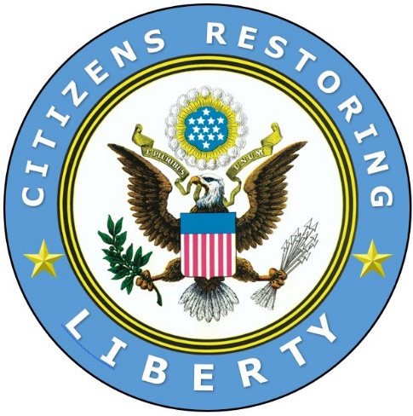
Your health is your responsibility.

Citizens Restoring Liberty
https://CRLiberty.com
https://DefendOurUnion.org
https://www.constitutionallawgroup.us

